FundAnything

-a Crowdfunding WebApp

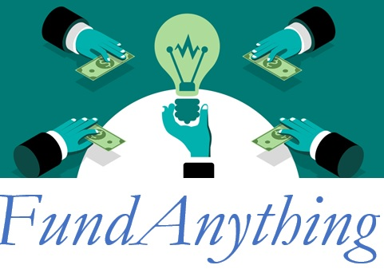

Shweta Patil  
StudentID: 800989198

10/02/2017

# FundAnything - A Crowdfunding Web Application

# **Project Name:** FundAnything - a Crowdfunding WebApp

# **Project Overview:**

We all love to dream and feel passionate about our ideas, but most of us struggle with the execution sometimes due to lack of initiative or sometimes due to insufficient funds. We may have great ideas but implementing ideas, if restricted by capital investment is an unfortunate case. Wouldn’t it be great if we don’t have to connect with the venture capitalists or banks for loans and just get the like-minded people to raise their funds for the ideas that we wish to implement?

***“Crowdfunding is the practice of funding a project or venture by raising funds contributions from a large number of people, typically via internet.”***

***-www.dictionary.com***

Let’s consider Anna’s case. She is a fashion designer and wants to start her own line of clothing her sense of fashion is interestingly different and her perspective is fresh.

There are many others like Anna, who have great ideas they want to execute, but lack enough funds. Now, wouldn't it be great if they got early feedback from people about their ideas or products, so that they can better cater to the needs of the interested minds who they wish to sell their product to?

Crowdfunding has raised more than five billion dollars since the last decade and it’s generating more interest every day within potential entrepreneurs and small business owners who want to take it to the next level. Crowds come to support you in return for some unique rewards and experiences. Through this you generate the fund and get the early buyers who believe in your product and would wait eagerly for its launch.

Emma is an IT Professional and has very less time to pursue her fashion interests and her enthusiasm to design her own clothes. She has her own designs but has not ever worked on them since college. She would like to support Anna because she's ready to share some of her exclusive designs with Emma and has also invited her to visit her studio and share suggestions. Like Emma there are many others who may be ready to fund Anna and support her in some way. She may invite them to see her designs and tell them about her innovative ideas, in exchange for some unique rewards like custom-made designer shirts or being able to name a product Anna is launching. Funding amount can vary from as small as $10 to the funding goal they have set for themselves. Once she gets the money she had asked for, she starts the clothing factory and gives the rewards to everyone just as promised.

FundAnything is the platform where people like Anna, Emma and many more can participate and run campaigns for their projects to raise money. FundAnything helps them to build the campaign, run it, promote it and enable the creators to collaborate with like-minded people. FundAnything is a global platform that offers the lowest fees in the market for its crowdfunding services. It keeps your personal data safe, respects integrity of intellectual property, also allowing you to market your talent well and harness money from it.

# **Site Map:**

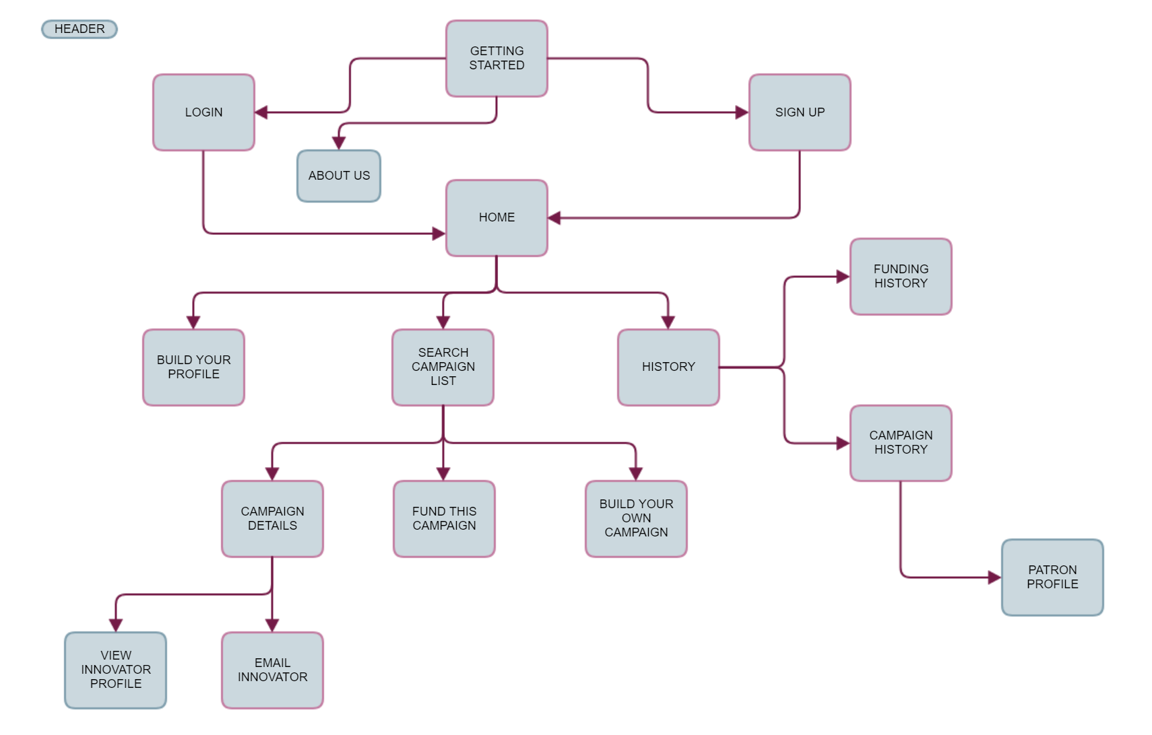

# **Page design**

### **Home**

* **Name:** Getting Started page
* **Purpose:** This is the landing page for any user when they hit the website URL. The home page will also hold some top trending projects which are popular among the patrons and have received high number of funds in the catalog
* **Audience**: Everyone is allowed access to this page. This will let new users signup for FundAnything or let existing users Login and navigate to Home page on successful login.
* **Buttons/ Hyperlinks and Actions:** This page will hold links to “Login”, “Sign Up and “About Us” pages.

### **About Us**

* **Name:** About Us
* **Purpose:** This page will let users know more about the website, its major contributors, what we do and how we run things around here. It also has a list of FAQs listed right on the page. In case of any queries or concerns, users may reach us using our “Contact Us” section listed on this page
* **Audience:** Everyone is allowed access to this page.

### **Sign Up**

* **Name:** Sign Up
* **Purpose:** Any interested user is welcome to be a part of FundAnything family by signing up with us. A person signing up can either be a “patron” or an “innovator”. “Patrons” are those willing to give to the community and provide financial backing to the “Innovators – these are people who hold amazing ideas and are looking for funds to bring their ideas to life”.
* **Audience:** Everyone is welcome to sign up with FundAnything.
* **I/O Fields:** “First Name”, “Last name”, “email”, “Contact no.”, “Address”, “City”, “Zip Code”.
* **Field Validations:** All fields will hold text validations.
* **Buttons/ Hyperlinks and Actions:** Upon passing the field validations, user will be able to signup successfully with the website. “Sign up” button will be placed at the end of the form. On successful sign up, user will be navigated to “Home Page”

### **Login**

* **Name:** Login
* **Purpose:** This page will allow existing users to log in to their FundAnything account using their “Email ID” and “Password” that they used to sign up with the website for the first time
* **Audience:** Existing users can use this page for logging in.
* **I/O Fields:** Email ID, Password
* **Field Validations:** Authenticity of the provided Email ID and password will be validated at the backend
* **Buttons/ Hyperlinks and Actions:** “Login” button will be placed at the end of the form. On successful sign up, user will be navigated to “Home Page”

### **Build your Profile**

* **Name:** Build your Profile
* **Purpose:** This page will allow members to build a profile for themselves which can reflect on their personality and interests, the kind of work they are doing, their interests and the goals that they aim to achieve by harnessing the resources that the website provides. Members can appeal other members to take interest in their initiatives.
* **Audience:** Member who has logged in, will have access to this page to build his own profile
* **I/O Fields**: “Preferred Name”, “What do you do for living”, “Contact email”, “Contact number”, “Current role”, “About you”, “Hobbies/ Interests”, “Goals”, “Quote”
* **Field Validations:** All fields will hold text validations
* **Buttons/ Hyperlinks and Actions:** This page will hold a “Save and Publish” button at the end of the form. Member can come back to this page to edit any details, so the page would also hold “Edit” button.

### **Search Campaign List**

* **Name:** Search Campaign List
* **Purpose**: This enables members to look at the existing campaigns and browse through them. The page holds all campaigns listed in alphabetical order. A search bar is enabled for users to search by name
* **Audience**: Members who have logged in will be able to see the campaign lists and consider the details of any campaign listed on the page.
* **I/O Fields:** Search bar
* **Field Validations:** Search
* **Buttons/ Hyperlinks and Actions:** This page will contain all campaign links to “Campaign Details” page. Upon clicking any campaign, members will be navigated to Campaign Details page.

### **History**

* **Name:** History
* **Purpose:** As the name suggests, this page will let users look at their “Campaign History” or “Funding History”
* **Audience:** All logged in members will be able to have a look at their history
* **Notes:** This page cannot be edited by the members. If there is any discrepancy, it is advised to email us. Upon confirmation, History will be edited considering proofs and facts.

### **Campaign Details**

* **Name:** Campaign details
* **Purpose:** This page will allow members to get a detailed view of any selected campaign. This page will contain details of the idea behind the campaign, its motivation and will include funding requirements of the “Innovator”.
* **Audience:** All logged in members will be able see existing campaign details as per their choice.
* **Buttons/ Hyperlinks and Actions:** “<3” button, “Fund this campaign”. Fund this campaign button will navigate the member to the Funding page.

### **Fund this Campaign**

* **Name:** Fund this Campaign
* **Purpose:** This page will allow users to pay funds to the innovator if they like the innovator’s campaign and believe in his idea. The funding amount can be as low as $10, and extend up to the maximum limit that the innovator has set for his campaign
* **Audience:** Any member who has logged in and has interests in funding a project can fund the campaign.
* **I/O Fields:** “Funding Amount”, “Feedback/ Suggestions”, “Comments”, “Card Details”.
* **Field Validations:** Text Field validations
* **Buttons/ Hyperlinks and Actions:** “Transfer funds”. This will complete transaction and deposit funds from Patron’s account to Innovators account.

### **Build your own Campaign**

* **Name:** Build your own Campaign
* **Purpose:** This page allows innovators to launch their idea to the website catalog. They can describe their campaign in as much detail as they would like.
* **Audience:** Any member can become an innovator and build a campaign
* **I/O Fields:** Title, Permanent Residence, Campaign Basics, Funding Rewards, Story-line
* **Field Validations:** Text Validations for all fields
* **Buttons/ Hyperlinks and Actions:** Save and Publish Campaign, Edit
* **Notes:** This page will hold a “Save and Publish” button at the end of the form. Member can come back to this page to edit any details, so the page would also hold “Edit” button.

### **Campaign History**

* **Name:** Campaign History
* **Purpose:** This page will hold details of all campaigns initiated till date. Members will also be able to see any emails sent by patrons to them and will able to respond to the emails
* **Audience:** A member who has logged in will be able to view his own campaign history, if any.
* **Buttons/ Hyperlinks and Actions:** “Respond” hyperlink at the end of every email from patron. “Profile” link to view “Patron” profile. Respond link will open a text box on the same page in the same place. On clicking “Patron” link, “innovator” will be navigated to view the “Patron” link.

### **Funding History**

* **Name: Funding History**
* **Purpose:** This page will hold details of all transactions initiated till date. Members will also be able to see any funding transactions performed by them.
* **Audience:** Members who logged in will be able see their Funding History, if any.

### **Patron Profile**

* **Name:** Patron Profile
* **Purpose:** This will show the profile of the patron to the innovator
* **Notes:** Innovators will not be able to initiate communication with the patrons by themselves unless the patrons express any interests. However, they will be able to view profiles of patrons who will initiate communication with them.

### **Email Innovator**

* **Name:** Email Innovator
* **Purpose:** This page allows member/ patron to initiate communication with the “Innovator”. This can include a feedback, an enquiry or any appreciation notes.
* **Audience:** Any member willing to fund a campaign will be able to email innovator from the Campaign details page
* **I/O Fields:** Valid email address, Subject Line, Email Body
* **Field Validations:** Text Validations
* **Buttons/ Hyperlinks and Actions:** Send button at the end of the email which will allow posting the email to the Innovator Profile.

### **View Innovator Profile**

* **Name:** View Innovator Profile
* **Purpose:** This will allow a member willing to fund a campaign, have a look at the “innovator” profile and learn more about the person. This profile will also hold a hyperlink to email the Innovator.
* **Audience:** Any member will be able to email innovator from the Campaign details page
* **Buttons/ Hyperlinks and Actions:** “Email” hyperlink to initiate communication with innovator.

**Header**

* A link to home page will be accessible from every page after the user has logged in. Website logo will serve as the Home page link for every page.
* Logout button will be present on every page that the user navigates to, after logging in.

**Footer**

* Sitemap

# **Project tasks, assignments and schedule:**

|  |  |  |  |
| --- | --- | --- | --- |
| # | Tasks | Start Date | End Date |
| 1 | Deliverables 1 – ERD | 10/ 02/ 2017 | 10/ 08/ 2017 |
| 2 | Design a database | 10/ 09/ 2017 | 10/ 15/ 2017 |
| 3 | Deliverable 2 - Progress | 10/ 16/ 2017 | 10/ 22/ 2017 |
| 4 | Coding specific pages | 10/ 23/ 2017 | 11/ 05/ 2017 |
| 5 | Coding functionalities | 11/ 06/ 2017 | 11/ 05/ 2017 |
| 6 | Testing completed application | 11/ 06/ 2017 | 11/ 19/ 2017 |
| 7 | User Manual | 11/ 20/ 2017 | 11/ 26/ 2017 |
| 8 | Presentation/ Demo | 11/ 27/ 2017 | 12/ 11/ 2017 |